Data Bricks
16 February 2026
14:02
Databricks
What is Databricks?
A cloud-based unified data analytics platform – simplified and accelerate – Data Engineering, Data Science, Machine Learning and Data Analytics.
  - Build on Apache Spark
  - Integrated seamlessly with cloud
  - Available – AWS, Azure, Google Cloud
  - Scalability
  - Collaborative Environment
  - Delta Lake –
  - Security and governance – Unity Catalog – Role based access control
Key Components
  - Workspaces – Collaborative Environment for Developer and manage data projects
    - Libraries, Notebooks, Dashboards
  - Clusters – Computation power to run logic, scalable
  - Databricks notebooks – write code in multiple languages and execute it
  - Jobs – Automated task like running a pipeline
  - Databricks Runtime – Optimized version of Apache Spark
  - Delta Lake – Asset Transaction
  - Unity Catalog – Data Governance
Uses Cases
  - Data Engineering – ETL(Extract, Transform, Load) pipelines, data ingestion, transformation
  - Data Science and Machine Learning
  - Business intelligence and analytics – SQL based queries on structured, unstructured and semi-structured data
  - Dashboards
  - Data Lakehouse
  - Real-time Analytics – stream processing
Limitations
  - Cost
  - Learning Curve
  - Dependency on cloud providers
  - Limited offline access

Databricks File System(DBFS)
Brief
  - Core and Heart of Databricks
  - Way to read and write data in Databricks
A distributed file system –
  - Split into pieces
  - Stored across many machines
  - But it looks like one big storage system to you
  - that abstracts storage infrastructure in Databricks
  - Build on top of cloud storage (Azure Data Lake Storage{ADLS}, Amazon S3 or Google Cloud Storage)
Key Features
  - Unified interface – access files and directories just as you access it in Local Machine
  - Seamless Integration – Databricks Workflows, clusters and notebooks
  - Access to Cloud – file is eventually getting stored in cloud
  - Scalable and Distributed
  - Data persistence – stored permanently
  - Multiple Layers – temporary storage for notebooks and small files
  - Workspace storage – ADLS, AWS3
DBFS Path Structure
  - Absolute Path : begin with /
Example: /mnt/data/sample.csv
  - Relative Path : relative to the current working directory
  - DBFS prefix : accessing programmatically using the dbfs:/ prefix
Example: dbfs:/mnt/data/sample.csv
DBFS Use Cases
  - Data loading – load in dataframe
  - Data writing
  - Backup and Archive
  - Collaboration – share with all the other team
DBFS Limitations
  - Dependence on cloud storage
  - Path restrictions – Cannot accessed it locally or out of workspace

Challenges in Data Engineering
26 February 2026
14:33

The Problem Before Databricks
  - Separate Platforms
Earlier, companies used:
  - One tool for Data Lake
  - One tool for Data Warehouse
  - One tool for ETL
  - One tool for AI/ML
  - One tool for BI dashboards
  - One tool for Governance
Too many tools.
This caused:
  - Data duplication (same data stored many times)
  - Data silos (teams working separately)
  - Security problems
  - Integration headaches
  - Vendor lock-in (data stuck in one company’s system)
Everything became complicated.

Databricks Lakehouse Architecture
25 February 2026
10:40

Databricks Lakehouse Architecture Overview
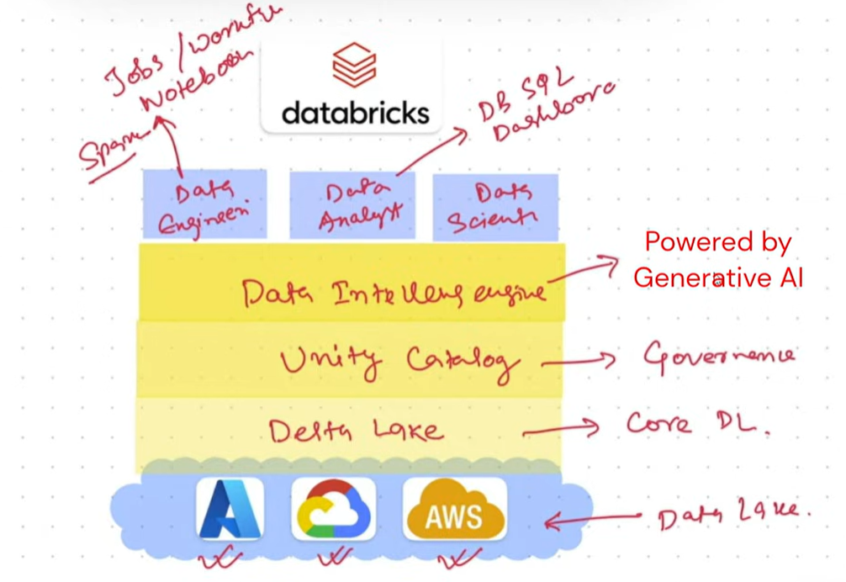

Cloud Storage
Your data is stored in AWS, Azure, or GCP.
It stays in open formats like Parquet or CSV.
So you are not locked to one vendor.

Delta Lake
This makes your data:
- Reliable
- Safe
- Version-controlled
- Like a database (no corruption)
It adds “database-like safety” to data lake storage.

Unity Catalog
This handles:
- Who can access what
- Security
- Tracking changes
- Data lineage (where data came from)

Data Intelligence Engine
This helps:
- Run faster queries
- Generate insights
- Support AI
- Use generative AI for smart analysis

Who Uses Databricks?
It supports all data roles:
- Data Engineers → Build pipelines, ETL, Spark jobs
- Data Analysts → Run SQL, build dashboards
- Data Scientists → Build AI/ML models

High-Level Architecture of Databricks
25 February 2026
11:43

High-Level Architecture -
a bird's-eye view of a system, showing its main components, how they interact, and the data flow without getting lost in technical details
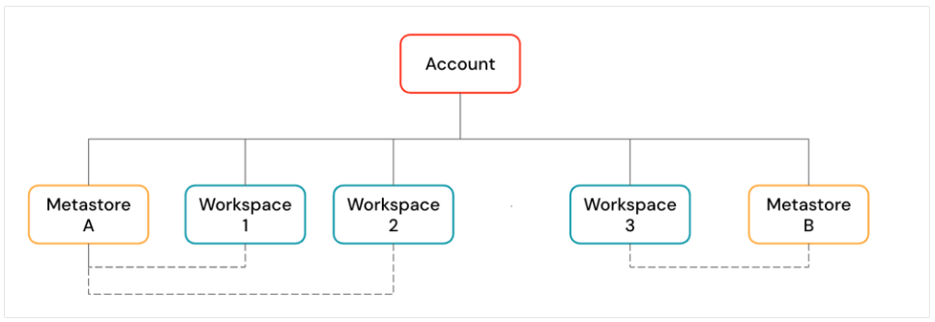
  - Databricks Account (Top-Level)
This is like the head office of your Databricks setup.
You manage things like:
  - Users & Permissions – who can access what
  - Workspaces – your actual working environments
  - Unity Catalog – a single place to organize & govern your data
  - Billing & Policies
Example:
Imagine a company "XYZ Corp":
  - The Databricks account is XYZ’s control center.
  - Under it, they create different workspaces for teams like:
    - Data Engineering Workspace
    - Machine Learning Workspace
  - An account can contain multiple workspaces and Unity Catalog metastores.

2. Workspaces (Where You Actually Work)
Workspaces are the collaboration environment where users run compute workloads such as ingestion, interactive exploration(playing with data), scheduled jobs, and ML training.
  - A workspace is like your office floor where people collaborate.
You can:
  - Run notebooks
  - Build pipelines
  - Train ML models
  - Run scheduled jobs
Example:
In AWS region Mumbai, you create a workspace where 10 engineers collaborate on data pipelines.

3. Unity Catalog (Data Governance System)
This is a central directory for all your data and models.
Data is organized like this:
<catalog-name>.<schema-name>.<object-name>

Example:
sales.ecommerce.orders
ml_models.fraud.random_forest_model
If multiple workspaces link to the same metastore, they all see the same data.

Reference Link - https://docs.databricks.com/aws/en/getting-started/high-level-architecture

Roles in Databricks
25 February 2026
12:08

  - Account Administrator (Top Level Boss)
Highest level control.
They manage:
  - Workspaces
  - Metastore
  - Users
  - Permissions
They control the entire Databricks account.
Think of them as the company owner.
2) Metastore Administrator
Manages data structure and governance.
They control:
  - Catalogs
  - Schemas
  - Tables (data objects)
This role works inside Unity Catalog.
They manage how data is organized and who can access it.
Think of them as the library manager of all company data.
  - Workspace Administrator
Manages one workspace.
They control:
  - Users inside that workspace
  - Clusters
  - Notebooks
  - Jobs
  - Workspace assets
They manage day-to-day workspace activities.
Think of them as the office manager of one branch.
  - Owner
Owns specific objects.
They can own:
  - Tables
  - Schemas
  - Notebooks
  - Dashboards
Owner controls that specific object.
Think of them as the creator of a file who can modify or delete it.
Simple Hierarchy
From highest control to lowest:
Account Admin
↓
Metastore Admin
↓
Workspace Admin
↓
Owner
In One Simple Line
  - Account Admin → Controls everything
  - Metastore Admin → Controls data structure
  - Workspace Admin → Controls workspace activities
  - Owner → Controls specific objects

Workspace architecture
25 February 2026
15:08

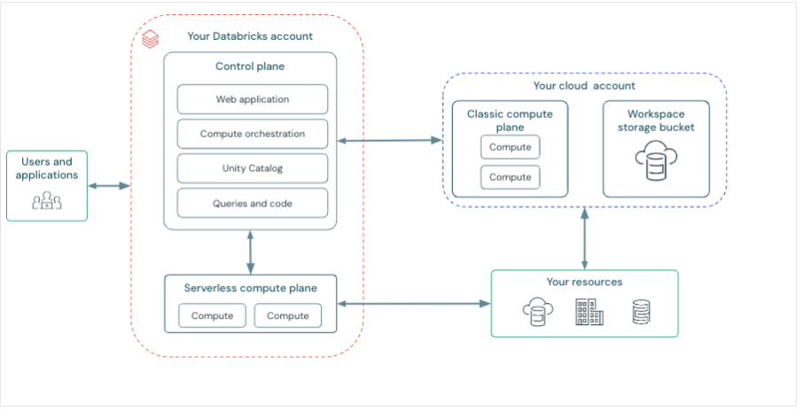
Databricks operates out of a control plane and a compute plane.
Control Plane
Managed by Databricks.
Contains:
  - The web UI
  - Backend services
  - Job scheduler
  - Workspace metadata
Think of it as Databricks’ brain — not in your cloud account.
Compute Plane
Where your data actually gets processed.
  - All clusters required for data processing are created at Customer Cloud Account.
  - No movement of data in Control Plane.
Two types:
A. Serverless Compute Plane (Databricks-managed)
  - Databricks allocates and manages compute for you
  - Runs inside Databricks’ cloud account
  - You don’t manage servers at all
  - Highly secure and isolated
Example:
You run a SQL warehouse and Databricks spins up the compute automatically.
B. Classic Compute Plane (Customer-managed)
  - Compute runs inside your AWS account
  - You manage VPCs, security, networking
Example:
You launch a cluster for Spark jobs inside your own AWS VPC.

  - Workspace Storage
Storage works differently for serverless vs classic workspaces.
  - Serverless Workspace Storage(Dynamic)
  - Databricks provides a default storage for all system and Unity Catalog data
  - You can also connect your own S3, GCS, etc.
Example:
You run a job and logs, notebook history, and internal files are stored automatically.
  - Classic Workspace Storage(Static)
You must provide your own S3 bucket.
Contains:
  - Notebook revisions
  - Job run details
  - Spark logs
  - Default Unity Catalog data

Reference Link - https://docs.databricks.com/aws/en/getting-started/high-level-architecture

Unity Catalog
25 February 2026
14:18
Unity Catalog is an open-source unified governance.
- Unified - define once, secure it everywhere.
- Governance - make data secure, available and accurate
Key Points
- Centralized
- Security
- Auditing
- Lineage - Past track of data, who changed what, when it changed, etc
- Data Discovery

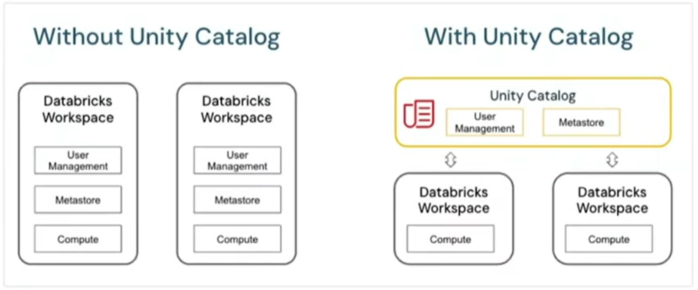

Unity Catalog(Databricks) object Model / Database Object Model
25 February 2026
15:08

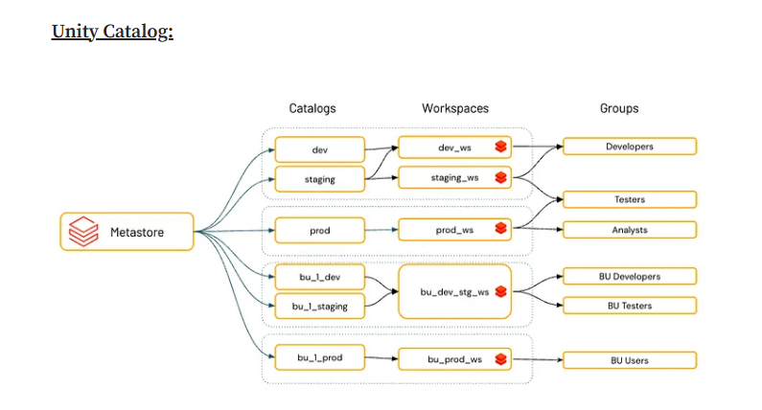

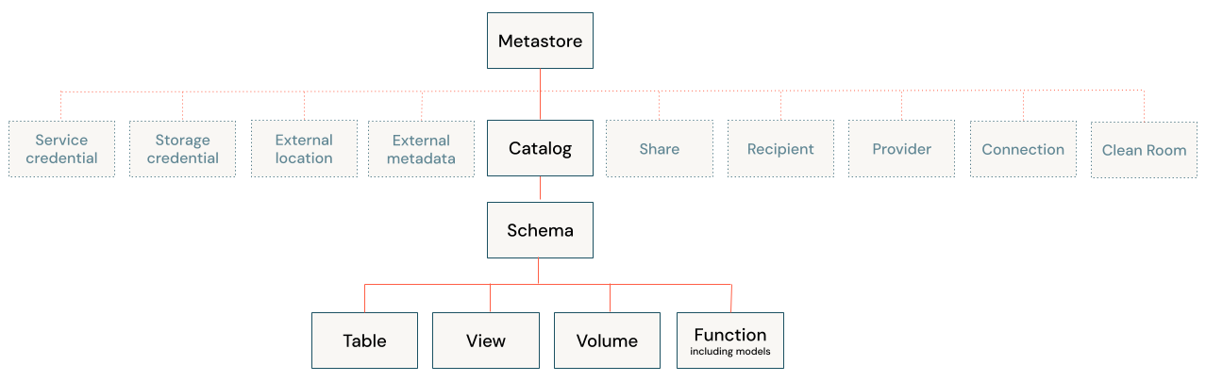
Metastore
  - The metastore is the top-level container for metadata in Unity Catalog.
  - It registers metadata about data and AI assets and the permissions that govern access to them.
  - For a workspace to use Unity Catalog, it must have a Unity Catalog metastore attached.
  - You should have one metastore for each region in which you have workspaces.
  - Managed by Control Plane
Objects
In Databricks, an "object" is simply anything used to store, manage, or work with data and AI assets.

Database objects in Databricks
Databricks uses two primary securable objects to store and access data.
  - Tables govern access to tabular data.
  - Volumes govern access to non-tabular data.

What are database objects in Databricks?
Database objects are entities that help you organize, access, and govern data.
Databricks uses a three-tier hierarchy to organize database objects:
These objects are primarily for organizing and governing your data, managed within a three-tier hierarchy:
Catalog -> Schema (or Database) -> Data Object
  - Catalog: The top level container, contains schemas.
  - Schema or database: Contains data objects.
  - Data objects that can be contained in a schema:
  - Volume: a logical volume of non-tabular data in cloud object storage.
  - Table: a collection of data organized by rows and columns.
  - View: a saved query against one or more tables.
  - Function: saved logic that returns a scalar value or set of rows.
  - Model: a machine learning model packaged with MLflow.

Location of Metastore
abfss://root@....../metastore/ <Metastore-id>

Hive Metastore vs Unity Catalog
27 February 2026
08:00

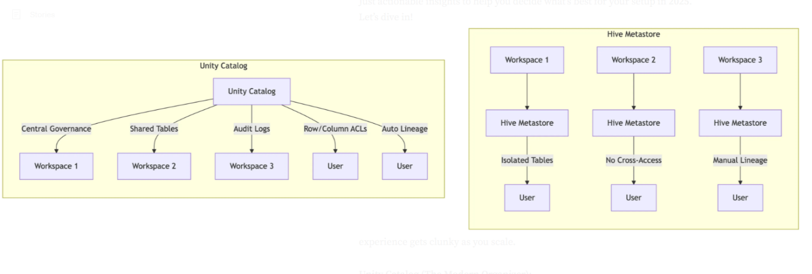
1. What They Are
Hive Metastore
- Legacy metadata store used in Hadoop and early Databricks.
- Manages tables and schemas.
- Reliable but outdated and not scalable across workspaces.
Unity Catalog
- Databricks’ modern governance layer.
- Manages data, AI models, notebooks, files, lineage, and permissions.
- Provides central, account-level governance across regions and clouds.

2. Architecture & Namespace
- Hive: database.table (2-level), limited to one workspace → causes silos.
- Unity Catalog: catalog.schema.table (3-level) → supports multi-workspace and multi-cloud.
Example benefit: teams across prod/dev or regions can access shared datasets.

3. Governance, Access Control & Security
Hive:
- Basic RBAC(Role Based Access Control) only.
- No built-in auditing(who accessed what).
Unity Catalog:
- Advanced governance: row/column-level access, ABAC, data masking.
- Automatic audit logging and integration with Azure AD.
- Prevents accidental drops/unauthorized access.

4. Data Lineage & Auditing
- Hive: No native lineage. Audits require external tools.
- Unity Catalog: Automatic end-to-end column-level lineage across workspaces, retained for ~1 year.

5. Data Format Support
- Hive: Works mostly with structured data (ORC, Parquet).
- Unity Catalog: Supports structured + unstructured data (JSON, CSV, images, logs, Delta Lake, more).
Much more flexible for IoT, AI, ML workloads.

6. Multi-Cloud & Scaling
- Hive: Single workspace, no multi-cloud support.
- Unity Catalog: Enterprise-grade, multi-workspace, multi-cloud (AWS/Azure/GCP).

7. Migration Strategies
- Hive can coexist through hive_metastore catalog.
- Two approaches:
  - Full migration (upgrade tables to UC)
  - Federation (map Hive into UC as a foreign catalog)
- Recommendation: Start with federation to avoid disruption.

8. Pros & Cons (High Level)
Hive — Pros
- Simple, battle-tested for small setups.
- Good for legacy workloads.
Hive — Cons
- No central governance.
- Poor security & auditing.
- Not built for multi-cloud or enterprise scale.
Unity Catalog — Pros
- Modern governance & fine-grained access control.
- Multi-cloud, multi-workspace.
- Native lineage and auditing.
- Handles all data types and AI assets.
Unity Catalog — Cons
- Migration required for legacy systems.

9. When Unity Catalog Is a Better Choice
- Data contains PII(Personally Identifiale Information) or needs masking.
- Multiple teams/regions need shared access.
- You require compliance (GDPR, HIPAA, financial audits).
- You want future-proof, AI-ready governance.

Reference Link - Unity Catalog vs Hive Metastore: Real-World Differences | by Prem Vishnoi(cloudvala) | EndToEndData | Medium
Hive Metastore
2 Tier-Architecture

Managed Table?
Both Table Metadata and Underlying Data Files are managed by the Table in Metastore.
- If table is dropped, all the inside data is also deleted.

Hive Warehouse Location?
The default managed location for Hive Catalog tables.
dbfs:/user/hive/warehouse/<schema_name.db>/<table_name>

External Table?
Only metadata is managed by table in Metastore.
Location is specified explicitly and underlying data files are not managed by the Table in Metastore.
- Underlying Data is not lost, even though table is dropped.
- Not supported in free-edition.

Managed Table vs External Table
02 March 2026
09:21
Managed Tables (Internal)
A managed table is fully controlled by the platform. It is the default table type in Unity Catalog.
  - Data Lifecycle: When you DROP a managed table, the platform deletes both the table metadata (schema) and the actual data files from storage.
  - Storage Location: The platform automatically handles where the files are stored (typically in a predefined "warehouse" or "root" storage directory).
  - Best For: Internal data pipelines where you want the platform to handle cleanup, backups, and predictive performance optimizations like automatic file compaction.
Unity Catalog Managed Table Locations
How managed table locations determined on different level in Unity Catalog Object Model.
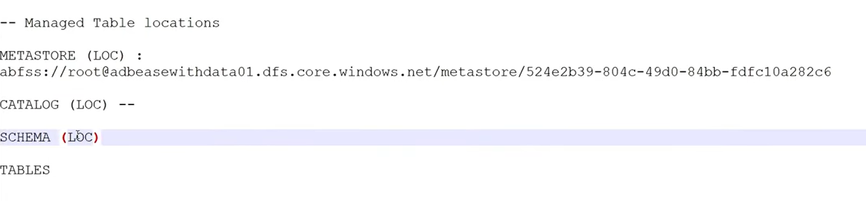
Fallback Mechanism
Managed table location will be
  - If Schema Location is specified, then table is created at Schema Location.
  - If Schema Location is not specified, then table will be created at Catalog Location.
  - If Schema and Catalog Location is not specified, then table will be created at Metastore Location.
  - If you have not specified default location while creating Metastore, then you have to specify Catalog Location.

Creating Catalog with External Location
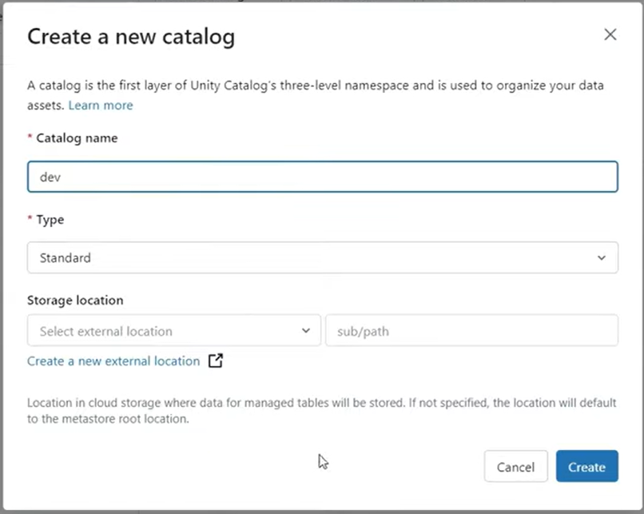

Dropping tables in case of Unity Catalog
  - Undrop Managed Tables in case of Unity Catalog
The UNDROP command addresses the concern of managed or external relations (tables or materialized views) located in Unity Catalog being accidentally dropped or deleted. By default, this command undrops (recovers) the most recently dropped relation owned by the user of the given relation name. The parent schema and catalog must exist. This feature supports recovering dropped relations within a 7 day retention period.
  - If there are multiple dropped relations of the same name, you can use SHOW TABLES DROPPED to identify the table ID and use UNDROP TABLE WITH ID to recover a specific relation.
  - If there is a relation with the same name as the relation you wish to recover, use ALTER TABLE RENAME TO command to change the name of the existing relation.
  - Table metadata – such as table privileges, column spec, and properties – will be recovered. Primary and foreign key constraints are not recovered by the UNDROP command. Recreate them manually using ALTER TABLE ADD CONSTRAINT after the table has been recovered.
SYNTAX -
UNDROP { MATERIALIZED VIEW | TABLE } { relation_name | WITH ID relation_id }
Eg: UNDROPPED TABLE WITH ID "acndjsncndjsn"

Reference Link - <https://docs.databricks.com/aws/en/sql/language-manual/sql-ref-syntax-ddl-undrop-table>

External Tables (Unmanaged)
An external table decouples the metadata from the physical data files.
  - Data Lifecycle: When you DROP an external table, only the metadata (the pointer to the data) is removed. The underlying data files remain intact in your cloud storage (e.g., S3, ADLS, or GCS).
  - Storage Location: You must specify a LOCATION path during creation, pointing to existing or new data in your own storage account.
  - Best For: Sharing data across different tools (e.g., Spark, Presto, or Snowflake) or when you need to retain the data even if the table is deleted from the workspace.
Comparison Summary
Feature | Managed Table | External Table
Data Ownership | Platform (e.g., Databricks/Hive) | User/External Storage
On DROP TABLE | Deletes Metadata and Data | Deletes Metadata only
Default Location | Warehouse directory | User-specified path
Optimizations | Full (Predictive, Auto-Vacuum) | Limited (Manual management)
Main Benefit | Simple management & performance | Flexibility & interoperability

Delta Ecosystem in Databricks
26 February 2026
14:43

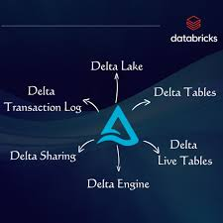

This image shows the Delta ecosystem inside Databricks — basically the core technologies that make Databricks powerful and reliable.
Think of it like this:
Databricks runs on something called the Lakehouse architecture, and Delta Lake is the foundation of that lakehouse.
Now let’s break each part in simple terms and see how it fits into Databricks.

Delta Lake
This is the foundation layer.
In simple words:
Delta Lake makes your data lake reliable like a database.
Normally, a data lake (like files stored in S3, ADLS, etc.) is just raw files.
Delta Lake adds:
- ACID transactions (safe reads and writes)
- Version control (time travel)
- Schema enforcement
- Better performance
Where it aligns in Databricks:
Everything you do in Databricks (tables, pipelines, jobs) typically sits on top of Delta Lake.

Delta Tables
These are tables stored using the Delta Lake format.
Simple meaning:
A Delta Table = data stored as files + transaction log for reliability.
Instead of plain Parquet files, Databricks stores data as Delta tables so:
- You can update and delete rows
- You can merge data
- You can query historical versions
Where it aligns:
When you create a table in Databricks using:
CREATE TABLE
or write data using Spark,
you are usually creating a Delta Table.

Delta Transaction Log
This is the brain behind Delta Lake.
Simple meaning:
It’s a log that tracks every change made to the data.
Whenever you:
- Insert data
- Update data
- Delete data
- Merge data
Delta writes a record in the transaction log.
Why this matters:
- Ensures data consistency
- Prevents corruption
- Enables time travel
Where it aligns:
Every Delta Table has a hidden _delta_log folder that tracks changes.

Delta Engine
This is the performance booster.
Simple meaning:
It’s an optimized engine that makes Delta queries faster.
It improves:
- Query speed
- Data skipping
- File pruning
- Execution optimization
Where it aligns:
When you run SQL or Spark queries in Databricks, the Delta Engine helps execute them efficiently.

Delta Live Tables (DLT)
This is for building data pipelines.
Simple meaning:
It helps you automatically build, manage, and monitor ETL pipelines.
Instead of writing complex pipeline logic manually, DLT:
- Handles dependencies
- Tracks data quality
- Manages incremental processing
Where it aligns:
Used in production workflows when building reliable data pipelines in Databricks.

Delta Sharing
This is for sharing data securely.
Simple meaning:
It allows you to share live data with other teams or even external companies — without copying data.
Where it aligns:
Used when organizations need secure cross-team or cross-company data sharing.

How All of This Fits into Databricks Workflow
Here’s how it connects in real working:
- You ingest data → store it as Delta Tables (on Delta Lake).
- Delta Transaction Log tracks every change.
- Delta Engine makes queries fast.
- Delta Live Tables builds pipelines on top of Delta.
- Delta Sharing lets you share that data externally.
So the alignment is:
Storage Layer → Delta Lake
Table Format → Delta Tables
Reliability Layer → Transaction Log
Performance Layer → Delta Engine
Pipeline Layer → Delta Live Tables
Collaboration Layer → Delta Sharing
All together, these components form the core data layer inside Databricks Lakehouse.

Hive vs Delta Tables
02 March 2026
13:34
Hive Table

Hive does not support support DML(Update, Delete, insert).

Creating Hive Table
- df_sales.write.format("parquet").mode("overwrite").option("path", "/data/output/sales_parquet_1/").saveAsTable("sales_parquet_1")

Delta Table

- df_sales.write.format("delta").mode("overwrite").option("path", "/data/output/sales_parquet_1/").saveAsTable("sales_parquet_1")
- It saves data in the form of Json.
- We can see versioning of Delta Table.
  - describe history <Table Name>
- Every DML operation creates a new json file.
- Time travel is possible in Delta Lake.
df_sales_delta = spark.read.table("sales_delta@version")
or
select * from sales_delta@version where ….
- Append data to existing table
  - df_new = spark.sql("select * , current_timestamp() as time_now from sales_delta@v where trx_id = '1395616'")
  - df_new.write.format("delta").mode("append").option("mergeSchema", True).option("path", "/data/output/sales_delta_1").saveAsTable("sales_delta")
- Convert parquet table to delta table
- Restore back to specific Version in Data Lake
- Vacuum operates in Delta Lake - To clean up history/ old versions of delta table

Some Important Commands
02 March 2026
09:46

  - Information about Catalog - DESCRIBE CATALOG EXTENDED <catalog_name>
  - Information about Table - DESCRIBE EXTENDED <table_name>
  - Create Catalog -
Create Catalog <Catalog Name>
COMMENT 'This is a comment';
  - Delete Catalog and Schema and Table inside it.
Drop Catalog <Catalog_Name> CASCADE

DataFrame in Spark
20 February 2026
10:00

What is Dataframe in spark?
A distributed collection of data organised into columns and rows.
- It is similar to Tables used in relational databases like PostgreSQL
- Abstraction of data processing(structured and semi-structured data)
- Long story short, it is used to represent your .csv, .json or parquet files, etc into rows and columns, we use Dataframes.

Key Features of DataFrames
- Schema-defined - specific column names and data types
- Distributed in nature - data is not stored in any one node or machine, it is stored across entire cluster
- Immutable - New dataframe is created every time, you make changes
- Optimized execution - Uses Spark's Catalyst Optimizer
- Support for various data sources - csv, json, parquet, etc

Spark SQL
05 March 2026
15:12

A module in Apache Spark that provides structured data processing using a SQL-like interface.
- Built on top of the Spark core.

Key Features
- SQL query interface
- Unified data access - structured, unstructured and semi-structured data
- Integration with Dataframe API
- Catalyst optimizer - Make query more efficient at the time of execution
- Support for schema enforcement - validation of schema

Why use Spark SQL?
- Ease of use
- Scalability
- Integration with big data ecosystems - Spark HDFS, ADB
- Performance - equivalent performance to Dataframe API
- Flexibility - mix match for Spark Sql and Dataframe API

Limitations
- Latency for small queries - Slower
- Complexity for advanced operations - use of Datafram API

Temporary Views
05 March 2026
15:21

A temporary view in Databricks is a session-scoped table-like structure created from a PySpark DataFrame.

